Three Dimensional FDFD with PML

Unsplitted PML equations
PML can be used to truncate 3D FDFD computational domain. The time harmonic PML equations in split form for 3D domain can be written as
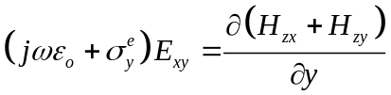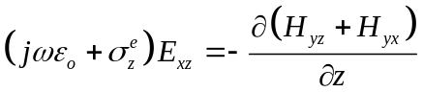
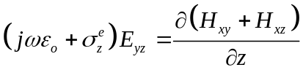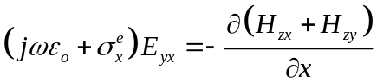
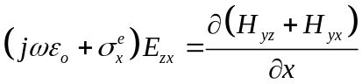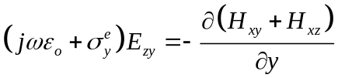
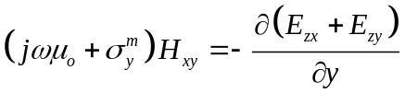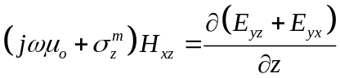
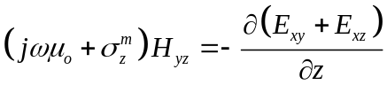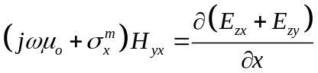
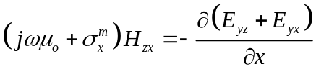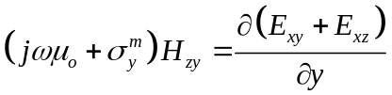
where . The original PML equations include splitted electric and magnetic field components. But in the time harmonic case, as in (1) and (2), the field components can be unified such that
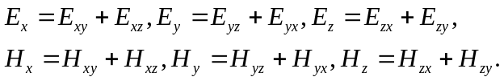
Then the sum of each pair in (1) and (2) will give unsplitted PML equations in 3D.
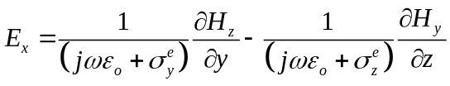
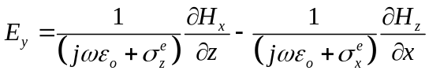
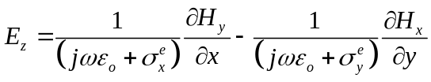
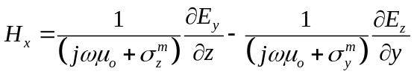
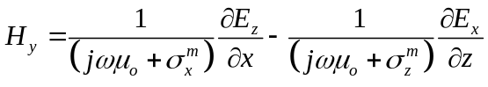
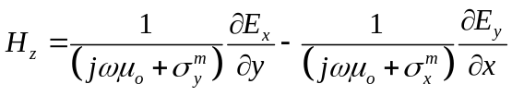

Maxwell’s equations in 3D splitted to vector components
Start with Maxwell’s curl equations in frequency domain. The time harmonic convention is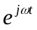.
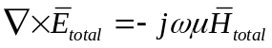
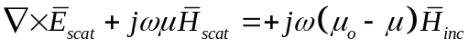
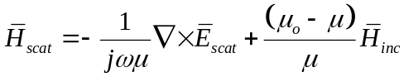

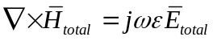
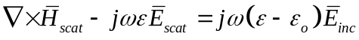
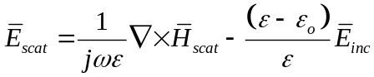
Equations (5) and (6) can be decomposed to x, y and z vector components as
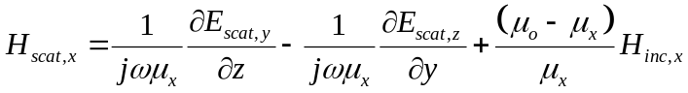
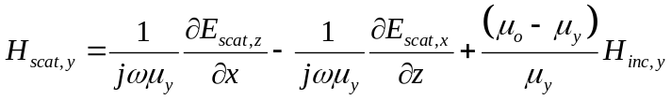
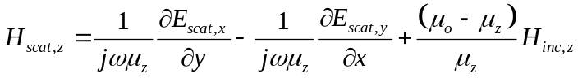
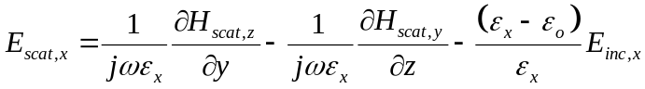
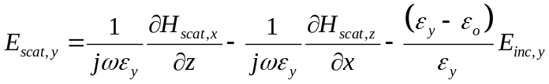
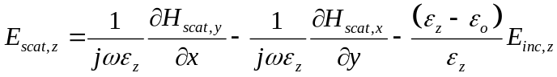
It should be noted that equations (3) are similar to (8) and (4) are similar to (7). Here we assume that PML is effective only on the scattered fields, thus (3) and (4) are for scattered fields. Using this similarity we can define a unified set of equations to represent the equations for both the PML and non-PML regions. The unified set of equations would be given as
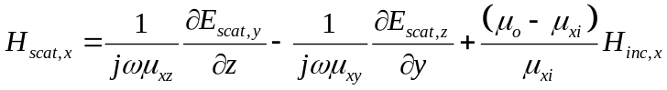
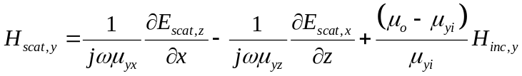
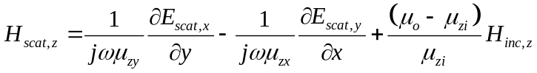
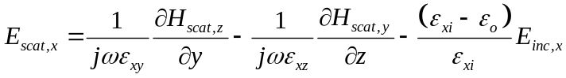
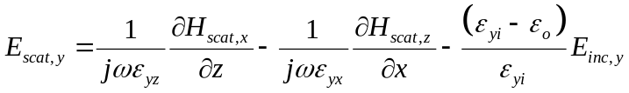
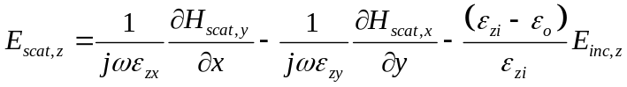
where it is assumed that in the non-PML region
and in the PML region
The conductivities in the PML region is calculated from
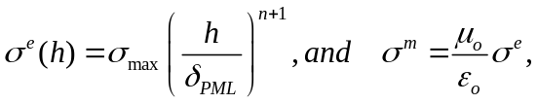
where
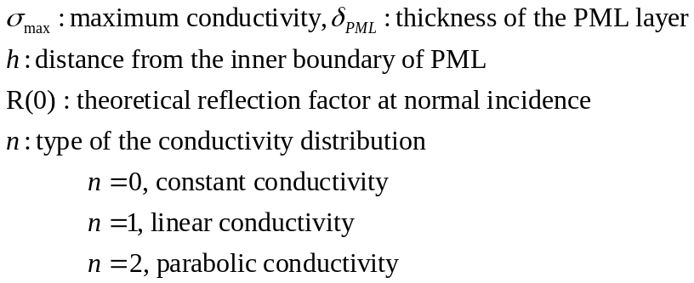
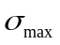 is defined as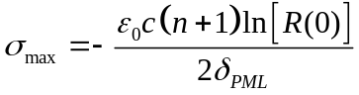.
The conductivities are defined only on the sides of the computational domain as shown in Fig. 1 and on the opposite sides and given with (11). Otherwise conductivities are zero.

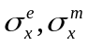
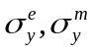
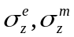

Figure 1. Conductivities over the computational domain.

Three Dimensional FDFD Equations
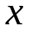
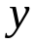
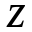
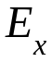
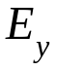
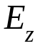
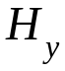
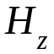
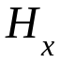
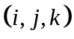
Equations (9) and (10) are the starting points for construction of FDFD equations.

Figure 2. 3D Yee grid.

Apply the central difference approximations to the derivatives in (9) and (10) and obtain the equations based on the Yee grid in Fig. 2.
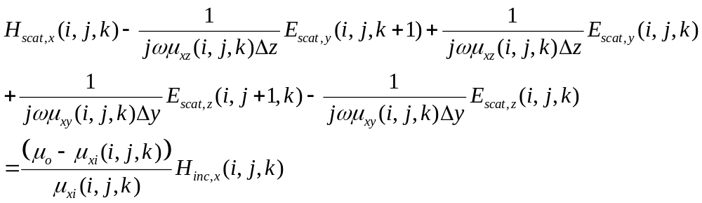
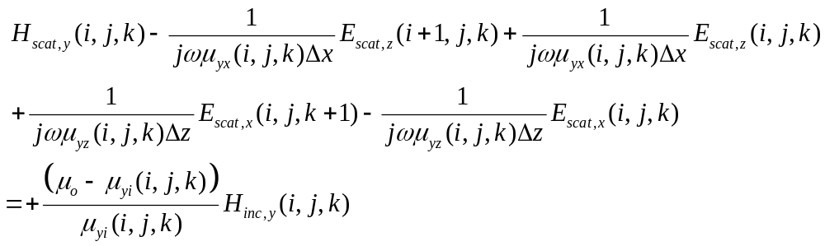
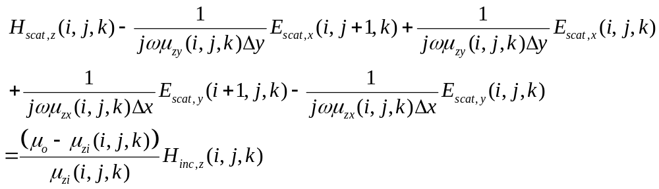
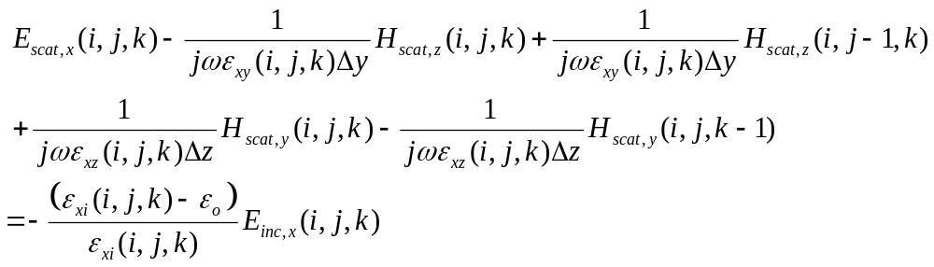
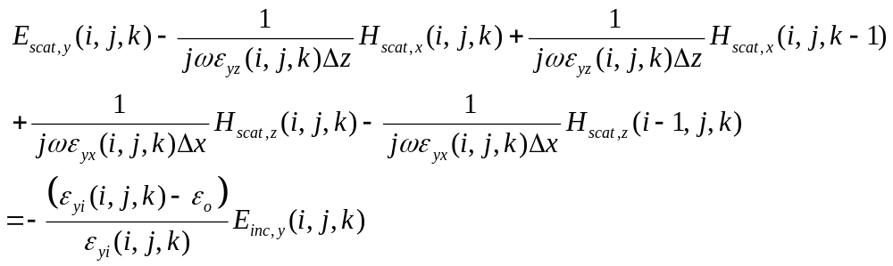
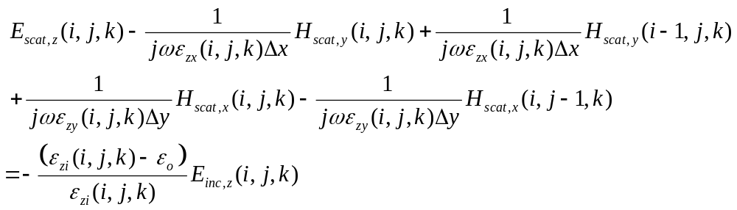

The equations relating the electric and magnetic fields can be put in the following form:
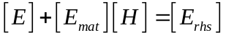(1)
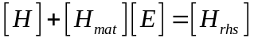(2)
Here the vectors and matrices are
Electric field vector 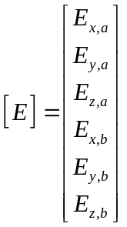,Magnetic field vector 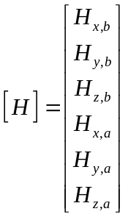
(2) can be written as
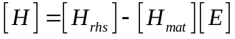(3)
Then electric field can be obtained using (3) in (1) as
(4)

